SCL OPERATIVE SECURITY CLEARANCE CARD  Name:  Classification:  Package:  Squad:  Dept: |  | Credits  Remaining    001-000000-11-00-1-000-11-000  Valid from: 1 / 900 Valid to: 12 / 906  Issued to  This card was issued by and remains the property of the  Department of Financial Services
This is to certify that  Name:  graduated from Meny approved training courses at a level sufficient to qualify as an operative of  Package  Valid from: 01/01/900  Employee Id code: 000000-11-00-1-000-11-000.  This card must be presented when accepting package restricted BPNs. | D.A.C. | The bearer of this card is performing business for  SLA Industries at the department of  and is accorded the rights, privileges and responsibilities of an operative of SLA as detail in the operative handbook. Misuse of this card is considered a breach of Contract of Employment.  Employee Id code: 000000-11-00-1-000-11-000  This card remains the property of the issuing department  Departmental Authorisation card
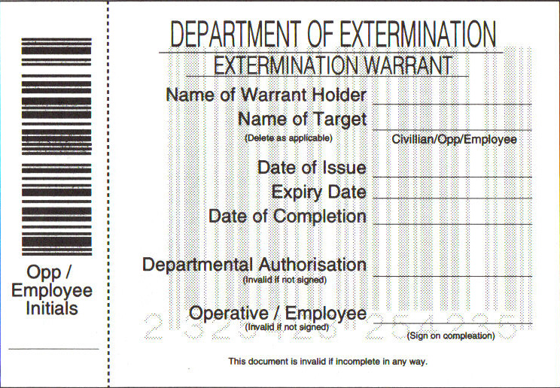 |  | 